EDSM Utilities

Descriptions

Each of these helps me do something for my EDSM hobby.

|  |  |
| --- | --- |
| downloader.sh | Downloads the daily json files. |
| uploader.sh | Uploads to my s3 bucket. |
| build-json-files.sh | Creates the json settings files for use in the pipeline. |

Procedures

Completion

Source this in your bash_profile to get it to work.

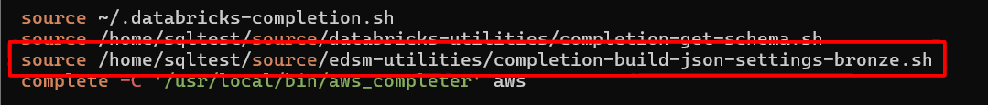

Download and Upload

To use these scripts run them directly from the edsm-utilities folder. The downloader should create a data folder, download all the files, and the uploader should put them up in the bucket.

./downloader.sh && ./uploader.sh

Build JSON Settings

Once you have the data files, you can build all the settings like this. Note: You need pyspark installed and working. Ask Chat GPT how to do that.

./build-json-settings-bronze.py --infolder data/20250621/ --outfolder settings/bronze/

Import Settings

Upload your settings into your workspace with this command. This script has the --overwrite argument so be careful.

./import-settings.py --color bronze --file settings/bronze/powerPlay.json

Or upload them all at once.

for file in settings/bronze/*; do ./import-settings.py --color bronze --file $file; done